Set 2: Customer Feedback Analysis
Dataset: Customer Satisfaction
Customer ID | Age | Satisfaction Score
1 | 25 | 4
2 | 30 | 5
3 | 35 | 3
4 | 28 | 4
5 | 40 | 5

Question 1: Histogram of Customer Ages
Create a histogram to represent the distribution of customer ages. Label the axes and title the chart.
Answer:
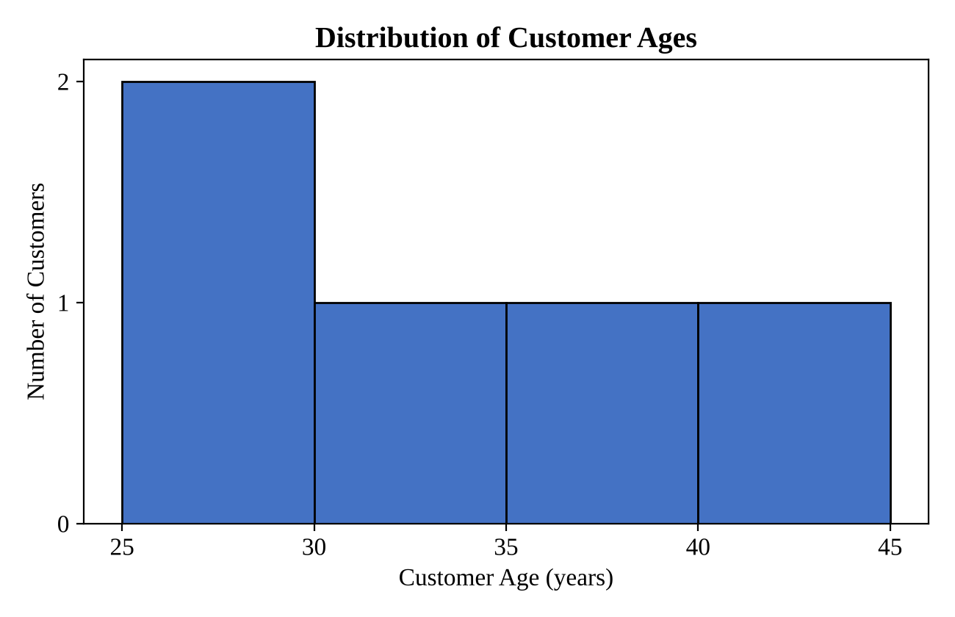
The five customers are between 25 and 40 years old. Using class intervals of five years, two customers fall in the 25–30 range (ages 25 and 28), and one customer each falls in the 30–35, 35–40 and 40–45 ranges. The 25–30 bar is therefore the tallest, which shows that the customer base leans towards the younger end, although with only five records the shape of the distribution should be read with care.
Question 2: Pie Chart of Satisfaction Scores
Generate a pie chart to display the overall distribution of customer satisfaction scores. Include labels.
Answer:
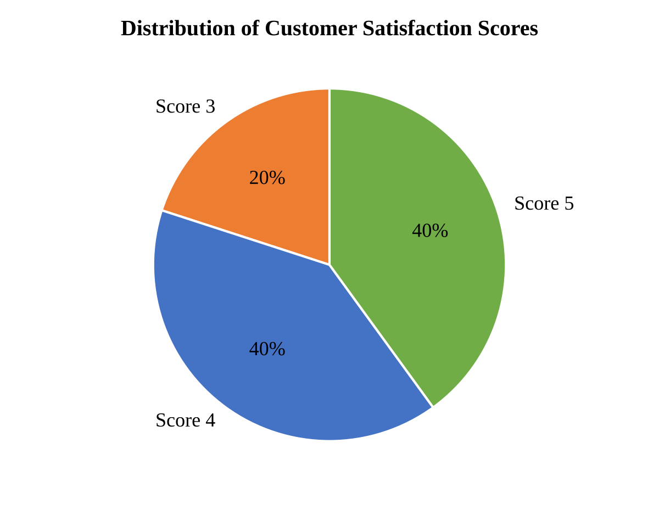
Out of the five customers, two gave a score of 4 (40%), two gave a score of 5 (40%) and one gave a score of 3 (20%). No customer gave a score of 1 or 2. Taken together, 80% of the customers rated their experience as 4 or higher, so overall satisfaction is high.
Question 3: Stacked Bar Chart by Age Group
Build a stacked bar chart to visualize the distribution of customer satisfaction scores by age group.
Answer:
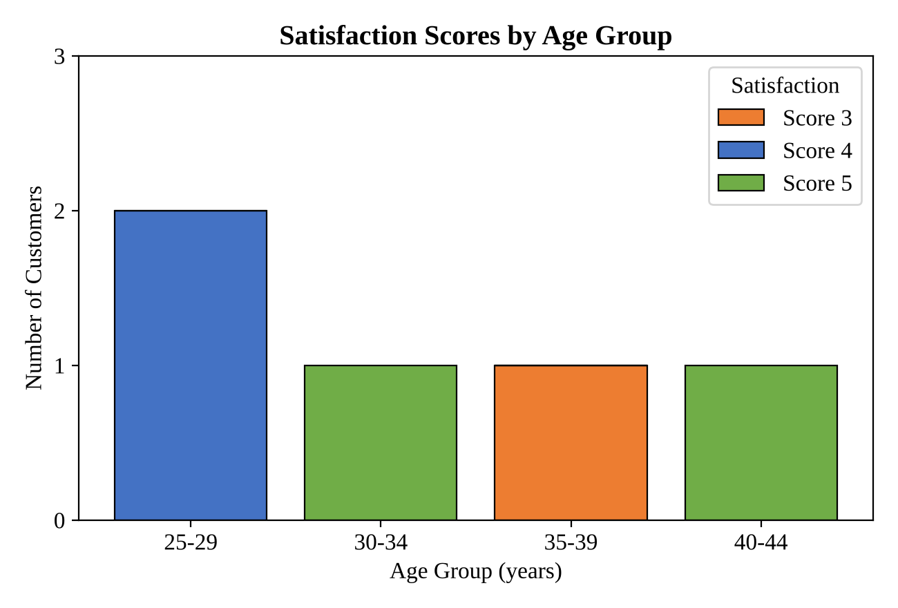
The customers were grouped into four age bands: 25–29, 30–34, 35–39 and 40–44. The counts of each satisfaction score within every band are shown below.
- 25–29 years: two customers, both with a score of 4.
- 30–34 years: one customer with a score of 5.
- 35–39 years: one customer with a score of 3.
- 40–44 years: one customer with a score of 5.
The only score of 3 comes from the 35–39 group, while the 30–34 and 40–44 groups both gave the top score. There is no clear link between age and satisfaction here, and the groups are too small to draw firm conclusions.
Question 4: Word Cloud of Customer Feedback
Develop a word cloud from open-ended customer feedback to identify prevalent customer sentiments.
Answer:
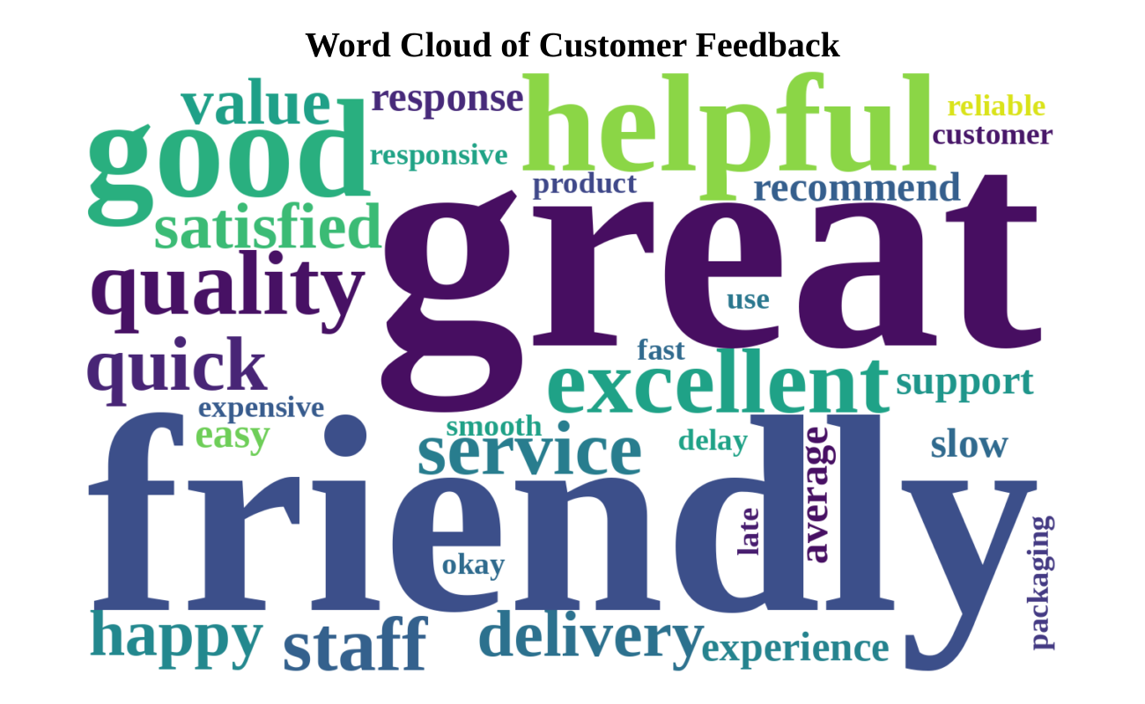
Note: the dataset provided contains only Customer ID, Age and Satisfaction Score, so it has no written feedback column. The word cloud above is therefore built from sample (illustrative) comments written to match the satisfaction scores. When the real open-ended responses are available, they can be pasted in and the cloud regenerated.
The most prominent words are positive ones such as “great”, “helpful”, “friendly”, “excellent”, “quality” and “service”, which fits the high satisfaction scores seen in the earlier charts. Smaller words such as “slow”, “delay”, “late” and “average” point to the main areas for improvement, namely delivery time and response speed.

